UNIVERSITY “POLITEHNICA” OF BUCHAREST
FACULTY OF ENGINEERING IN FOREIGN LANGUAGES
Software Engineering M.Sc.

SOFTWARE ENGINEERING
Topic:
Designing an application that converts University grades
between Romanian and American education systems.
(SOFTWARE DESING DOCUMENT)

PROFESSOR: STUDENT: SI. Dr. Ing. NICOLAE GOGA MAME AMATH DIAW

ASSISTANTS:
Ing. ALEXANDRA TODIRUTA
Ing. LUCIAN PESTRITU

Created Date:
JANUARY 2013
BUCHAREST

Delivery Report
(Will be delivered along with the project)

Name Group Project implementation [%, reason] Signature

_______________ ______ ____________________________ _________
____________________________
____________________________

_______________ ______ ____________________________ _________
____________________________
____________________________

_______________ ______ ____________________________ _________
____________________________
____________________________

Delivery date:
__________________________________

Table of Contents

1.1. Purpose 4
1.2. Target Public 4
1.3. Definitions, Acronyms and Abbreviations 4
1.4. Document Structure 4

2. References 5

3. Decomposition Description 6
3.1. Modules Description 6

4. Dependency Description 8

5. Interface Description 9

6. Detailed Design 10

A3. Sequence diagrams 11

System Design
According to the IEEE STD-1016-1998, IEEE Recommended Practice for Software Design Descriptions.

1. Introduction

1.1. Purpose
Grading systems vary significantly from country to country. The purpose of a University Grading Policy is to ensure that:
- grading practices throughout the University reflect appropriate academic standards;
- the evaluation of student performance is made in a fair and objective manner against these academic standards;
- the academic standing of every student can be accurately assessed even when courses have been taken in different divisions of an university and evaluated according to different grade scales.

Within the field of international education, the interpretation of foreign grades into national ones can be a very sensitive issue. Taking Romania and the United States as an example, the distribution of grades tend to be different.
In Romania the grades are between 1 and 10 and the average is calculated using the AVG formula. The US uses the so called Grade Point Average (GPA) system. The grades are from 0 - 4 and have an associated letter A (4), B (3), C (2), D (1), E/F (0). The GPA is calculated using the GPA formula.
This can be a major issue for international students returning after a study period abroad and for university staff required to assess the credentials of foreign applicants.

The purpose of this document is to design an application that converts University grades between Romanian and American education systems. The student will input his/her grades in the Romanian system and the program will then compute the AVG using the Romanian formula, then it will compute the equivalent US grade for each course, followed by the GPA.

3. Decomposition Description

Grade Conversion System
1. Course Name
1.1 Course Name 1
1.2 Course Name 2
1.3 Course Name 3
1.4 Course Name 4
2. Grades
1.5 Course Name 5

1.6 Course Name 6

1.7 Course Name 7

1.8 Course Name 8

3. Credits

Figure 3.1: Decomposition Description Diagram.

4. Dependency Description

<html>
<head>
<title> Grade Conversion
</title>

</head>
<body>

<h4><center>
<font color="orange">SOFTWARE ENGINEERING PROJECT <br>
UNIVERSITY GRADES CONVERTOR (ROMANIA - UNITED STATES)<BR>
</font>
</center></h4>

<CENTER>
<FORM Name="GPACalcForm">
<TABLE BORDER=5 BGCOLOR=#EDF7F2 CELLPADDING="5"
CELLSPACING="2">
<TH>Course Name</TH>
<TH>Grade</TH>
<TH>Credits</TH>
<TR>
<TD>Course Name 1</TD>
<TD><INPUT TYPE=TEXT SIZE=5 NAME="GR1" ALIGN=TOP
MAXLENGTH=5></TD>
<TD><INPUT TYPE=TEXT SIZE=5 NAME="CR1" ALIGN=TOP
MAXLENGTH=5></TD>
</TR>
<TR>
<TD>Course Name 2</TD>
<TD><INPUT TYPE=TEXT SIZE=5 NAME="GR2" ALIGN=TOP
MAXLENGTH=5></TD>
<TD><INPUT TYPE=TEXT SIZE=5 NAME="CR2" ALIGN=TOP
MAXLENGTH=5></TD>
</TR>
<TR>
<TD>Course Name 3</TD>
<TD><INPUT TYPE=TEXT SIZE=5 NAME="GR3" ALIGN=TOP
MAXLENGTH=5></TD>
<TD><INPUT TYPE=TEXT SIZE=5 NAME="CR3" ALIGN=TOP
MAXLENGTH=5></TD>
</TR>
<TR>
<TD>Course Name 4</TD>
<TD><INPUT TYPE=TEXT SIZE=5 NAME="GR4" ALIGN=TOP
MAXLENGTH=5></TD>
<TD><INPUT TYPE=TEXT SIZE=5 NAME="CR4" ALIGN=TOP
MAXLENGTH=5></TD>
</TR>
<TR>
<TD>Course Name 5</TD>
<TD><INPUT TYPE=TEXT SIZE=5 NAME="GR5" ALIGN=TOP
MAXLENGTH=5></TD>
<TD><INPUT TYPE=TEXT SIZE=5 NAME="CR5" ALIGN=TOP
MAXLENGTH=5></TD>
</TR>
<TR>
<TD>Course Name 6</TD>
<TD><INPUT TYPE=TEXT SIZE=5 NAME="GR6" ALIGN=TOP
MAXLENGTH=5></TD>
<TD><INPUT TYPE=TEXT SIZE=5 NAME="CR6" ALIGN=TOP
MAXLENGTH=5></TD>
</TR>
<TR>
<TD>Course Name 7</TD>
<TD><INPUT TYPE=TEXT SIZE=5 NAME="GR7" ALIGN=TOP
MAXLENGTH=5></TD>
<TD><INPUT TYPE=TEXT SIZE=5 NAME="CR7" ALIGN=TOP
MAXLENGTH=5></TD>
</TR>
<TR>
<TD>Course Name 8</TD>
<TD><INPUT TYPE=TEXT SIZE=5 NAME="GR8" ALIGN=TOP
MAXLENGTH=5></TD>
<TD><INPUT TYPE=TEXT SIZE=5 NAME="CR8" ALIGN=TOP
MAXLENGTH=5></TD>
</TR>
<TR ALIGN=CENTER>
<TD COLSPAN=3><INPUT TYPE="BUTTON" VALUE="Calculate"
NAME="CalcButton"
OnClick="gpacalc()">

<input type="button" name="reset_form" value="Clear" onclick="this.form.reset();">
</TD>

</TR>
</TABLE>
</FORM>
<BR>
<P>

<P>
</CENTER>

<BR>

<SCRIPT LANGUAGE="JavaScript">

<!--
function gpacalc()
{
//define valid grades and their values
var gr = new Array(9);
var cr = new Array(9);
var ingr = new Array(5);
var incr = new Array(5);

// define valid grades and their values
var grcount = 11;
gr[0] = "A+";
cr[0] = 5;
gr[1] = "A";
cr[1] = 4;
gr[2] = "A-";
cr[2] = 3.66;
gr[3] = "B+";
cr[3] = 3.33;
gr[4] = "B";
cr[4] = 3;
gr[5] = "B-";
cr[5] = 2.66;
gr[6] = "C+";
cr[6] = 2.33;
gr[7] = "C";
cr[7] = 2;
gr[8] = "C-";
cr[8] = 1.66;
gr[9] = "D";
cr[9] = 1;
gr[10] = "F";
cr[10] = 0;
// retrieve user input
ingr[0] = document.GPACalcForm.GR1.value;
ingr[1] = document.GPACalcForm.GR2.value;
ingr[2] = document.GPACalcForm.GR3.value;
ingr[3] = document.GPACalcForm.GR4.value;
ingr[4] = document.GPACalcForm.GR5.value;
ingr[5] = document.GPACalcForm.GR6.value;
ingr[6] = document.GPACalcForm.GR7.value;
ingr[7] = document.GPACalcForm.GR8.value;
incr[0] = document.GPACalcForm.CR1.value;
incr[1] = document.GPACalcForm.CR2.value;
incr[2] = document.GPACalcForm.CR3.value;
incr[3] = document.GPACalcForm.CR4.value;
incr[4] = document.GPACalcForm.CR5.value;
incr[5] = document.GPACalcForm.CR6.value;
ingr[6] = document.GPACalcForm.GR7.value;
ingr[7] = document.GPACalcForm.GR8.value;

// Calculate GPA
var allgr =0;
var allcr = 0;
var gpa = 0;
for (var x = 0; x < 5 + 3; x++)
{
if (ingr[x] == "") break;

var validgrcheck = 0;
for (var xx = 0; xx < grcount; xx++)
{
if (ingr[x] == gr[xx])
{
allgr = allgr + (parseInt(incr[x],10) * cr[xx]);
allcr = allcr + parseInt(incr[x],10);
validgrcheck = 1;
break;
}
}
if (validgrcheck == 0)
{
alert("Error - Could not recognize the grade entered for Course Name " + eval(x + 1) + ". Please use standard university grades in the form of A A- B+ ...F.");
return 0;
}
}

if (allcr == 0)
{
alert("Error - You did not enter any credit values! GPA = N/A");
return 0;
}

gpa = allgr / allcr;

alert("GPA = " + eval(gpa));

return 0;
}

//-->

</SCRIPT>

</body>
</html>

5. Interface Description

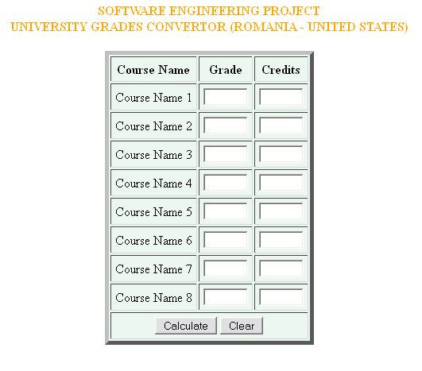
Figure 5.1: Grade conversion Application

GPA Calculation:
Enter Grade = A and Credit = 9, then GPA = 4.

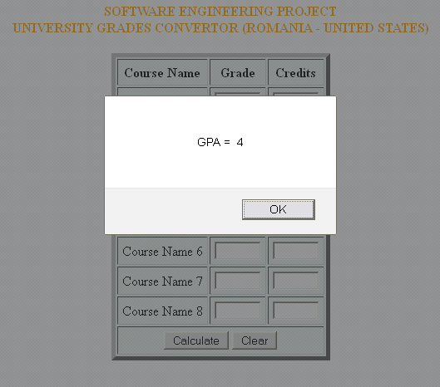

Figure 5.2: Valid GPA after conversion.
Grade must be from A, A-, B+ ...F.
Credits must be from 1 to 10.
Otherwise an error message is displayed.

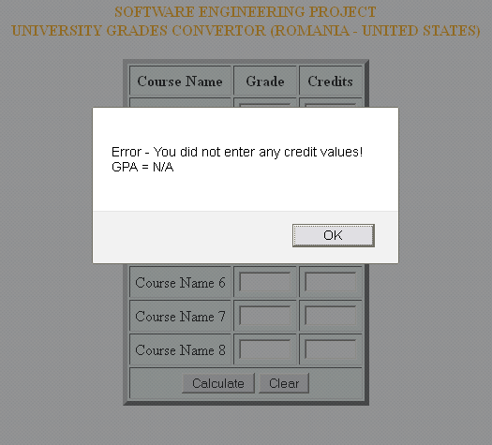

Figure 5.3: Error message after entering invalid data.

6. Detailed Design

Grade conversion System

Grades
Course Name
Credits

Course Name 1
Grade A(4)
Credit (1)

Credit (2)
Course Name 2
Grade B(3)
Credit (3)

Course Name 3
Grade C(2)
Credit (4)

Course Name 4
Grade D(1)
Credit (5)

Credit (6)
Course Name 5
Grade E/F(0)

Credit (7)
Course Name 6
Credit (8)

Course Name 8
Course Name 7
Credit (9)
Credit (10)

Figure 6.1: The Detailed Design of the application.

A3. Sequence Diagram

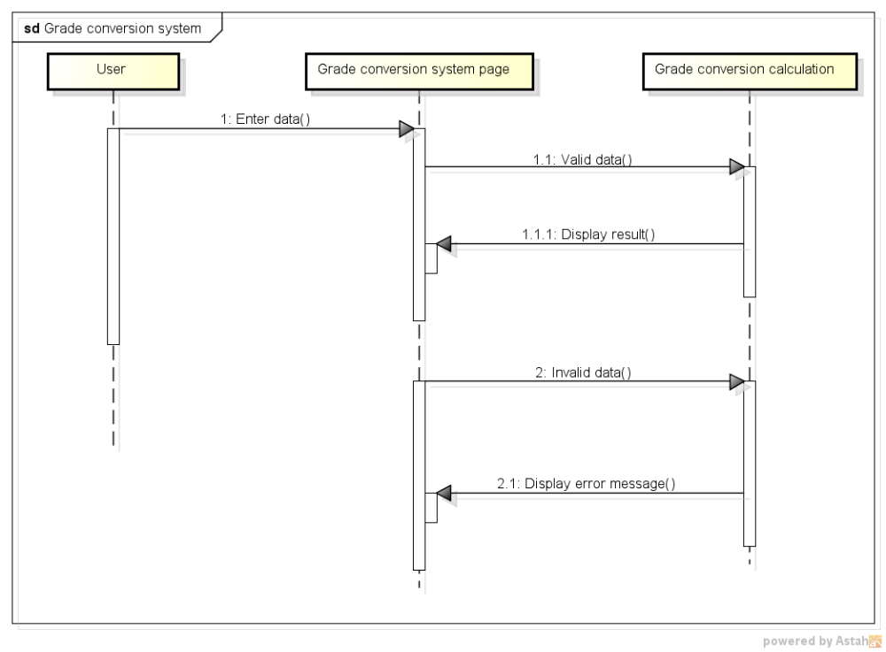

Figure A.3.1: Full Sequence Diagram of the application.

